1. **Write a program to generate Fibonacci series**

import java.io.*;

class Fibonacci

{

public static void main(String args[]) throws IOException

{

BufferedReader br=new BufferedReader(new InputStreamReader(System.in));

System.out.println("enter the no of fibonacci's");

int n=Integer.parseInt(br.readLine());

int f1=0,f2=1,f3=0;

System.out.print(f1+"\t"+f2);

int count=2;

while(count<n)

{

f3=f1+f2;

System.out.print("\t"+f3);

f1=f2;

f2=f3;

f3=f1+f2;

count++;

}

}

}

**OUTPUT:**

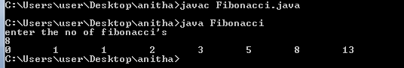

**2. Write a program to check whether the given year is Leap year or not**

import java.io.*;

class Leap

{

public static void main(String args[]) throws IOException

{

BufferedReader br=new BufferedReader(new InputStreamReader(System.in));

System.out.println("enter the year");

int yr=Integer.parseInt(br.readLine());

if((yr%100==0)&&(yr%400==0))

System.out.println(yr+"is a leap year");

else if((yr%100!=0)&&(yr%4==0))

System.out.println(yr+"is a leap year");

else

System.out.println(yr+"is not a leap year");

}

}

**OUTPUT**:

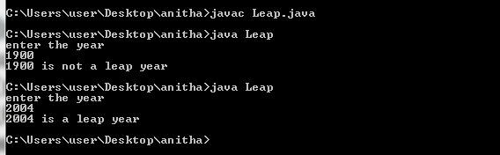

3. **Write a program to check whether the given number is Armtrong or not**

import java.io.*;

class Amstrong

{

public static void main(String args[]) throws IOException

{

System.out.println("enter the number");

BufferedReader br=new BufferedReader(new InputStreamReader(System.in));

String str=br.readLine();

int len=str.length();

int num=Integer.parseInt(str);

int temp=num;

double sum=0;

while(num!=0)

{

int rem=num%10;

sum=sum+(double)Math.pow(rem,len);

num=num/10;

}

if(sum==temp)

System.out.println(temp+" is a amstrong number");

else

System.out.println(temp+" is not an amstrong number");

}

}

**OUTPUT:**

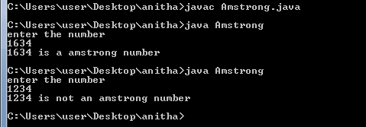

**4. Write a program to check whether the given number is perfect or not**

import java.io.*;

class Perfect

{

public static void main(String args[]) throws IOException

{

BufferedReader br=new BufferedReader(new InputStreamReader(System.in));

System.out.println("enter the number");

int n=Integer.parseInt(br.readLine());

int i=1,sum=0;

while(i<n)

{

if(n%i==0)

sum=sum+i;

i++;

}

if(n==sum)

System.out.println(n+" is a perfect number");

else

System.out.println(n+" is not a perfect number");

}

}

**OUTPUT:**

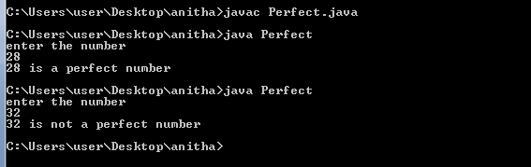

**5. Write a program to find transpose of a given matrix**

import java.util.*;

class Transpose

{

public static void main(String args[])

{

Scanner sc=new Scanner(System.in);

System.out.println("enter the no of rows");

int r=sc.nextInt();

System.out.println("enter the no of columns");

int c=sc.nextInt();

int a[][]=new int[r][c];

System.out.println("enter the elements of the array");

for(int i=0;i<r;i++)

{

for(int j=0;j<c;j++)

{

a[i][j]=sc.nextInt();

}

}

System.out.println("elements of the array before transpose");

for(int i=0;i<r;i++)

{

for(int j=0;j<c;j++)

{

System.out.print(a[i][j]+" ");

}

System.out.println();

}

System.out.println("elements of the array after transpose");

for(int i=0;i<c;i++)

{

for(int j=0;j<r;j++)

{

System.out.print(a[j][i]+" ");

}

System.out.println();

}

}

}

**OUTPUT:**

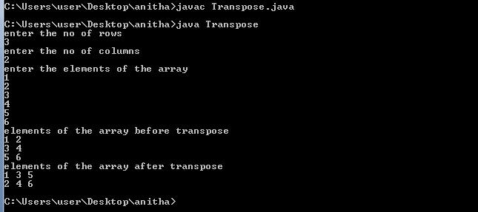

**6. Write a program to add two matrices**

import java.util.*;

class Add

{

public static void main(String args[])

{

Scanner sc=new Scanner(System.in);

System.out.println("enter the no of rows");

int r=sc.nextInt();

System.out.println("enter the no of columns");

int c=sc.nextInt();

int a[][]=new int[r][c];

int b[][]=new int[r][c];

System.out.println("enter the elements of the first array");

for(int i=0;i<r;i++)

{

for(int j=0;j<c;j++)

{

a[i][j]=sc.nextInt();

}

}

System.out.println("enter the elements of the second array");

for(int i=0;i<r;i++)

{

for(int j=0;j<c;j++)

{

b[i][j]=sc.nextInt();

}

}

System.out.println("elements of the first array");

for(int i=0;i<r;i++)

{

for(int j=0;j<c;j++)

{

System.out.print(a[i][j]+" ");

}

System.out.println();

}

System.out.println("elements of the second array");

for(int i=0;i<r;i++)

{

for(int j=0;j<c;j++)

{

System.out.print(b[i][j]+" ");

}

System.out.println();

}

System.out.println("elements of the array after addition");

for(int i=0;i<r;i++)

{

for(int j=0;j<c;j++)

{

System.out.print(a[i][j]+b[i][j]+" ");

}

System.out.println();

}

}

}

**OUTPUT:**

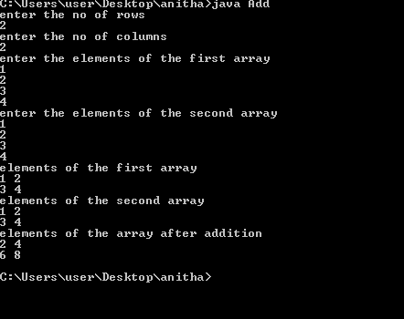

**7. Write a program to multiply two matrices**

import java.util.*;

class Multiplication

{

public static void main(String args[])

{

Scanner sc=new Scanner(System.in);

System.out.println("enter the no of rows of first matrix");

int r1=sc.nextInt();

System.out.println("enter the no of columns of frist matrix");

int c1=sc.nextInt();

System.out.println("enter the no of rows of second matrix");

int r2=sc.nextInt();

System.out.println("enter the no of columns of second matrix");

int c2=sc.nextInt();

int a[][]=new int[r1][c1];

int b[][]=new int[r2][c2];

int result[][]=new int[r1][c2];

System.out.println("enter the elements of the first array");

for(int i=0;i<r1;i++)

{

for(int j=0;j<c1;j++)

{

a[i][j]=sc.nextInt();

}

}

System.out.println("enter the elements of the second array");

for(int i=0;i<r2;i++)

{

for(int j=0;j<c2;j++)

{

b[i][j]=sc.nextInt();

}

}

System.out.println("elements of the first array");

for(int i=0;i<r1;i++)

{

for(int j=0;j<c1;j++)

{

System.out.print(a[i][j]+" ");

}

System.out.println();

}

System.out.println("elements of the second array");

for(int i=0;i<r2;i++)

{

for(int j=0;j<c2;j++)

{

System.out.print(b[i][j]+" ");

}

System.out.println();

}

if(c1!=r2)

System.out.println("Multiplication not possile");

else

{

for(int i=0;i<r1;i++)

{

for(int j=0;j<c2;j++)

{

for(int k=0;k<c1;k++)

{

result[i][j]+=a[i][k]*b[k][j];

}

}

}

}

System.out.println("elements of the array after multiplication");

for(int i=0;i<r1;i++)

{

for(int j=0;j<c2;j++)

{

System.out.print(result[i][j]+" ");

}

System.out.println();

}

}

}

**OUTPUT:**

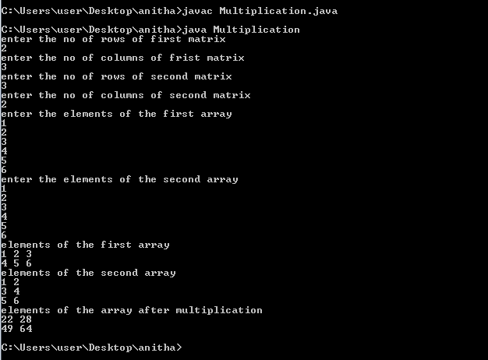

8. **Write a program to sort the array using bubble sorting technique**

import java.util.*;

class Bubble

{

public static void main(String args[])

{

Scanner sc=new Scanner(System.in);

System.out.println("enter the size of the array");

int n=sc.nextInt();

int a[]=new int[n];

System.out.println("enter the elements into the array");

for(int i=0;i<n;i++)

a[i]=sc.nextInt();

System.out.println("Array elements before sorting :");

for(int i=0;i<n;i++)

System.out.print(a[i]+" ");

for(int i=0;i<n;i++)

{

for(int j=i+1;j<n;j++)

{

if(a[i]>a[j])

{

int temp=a[i];

a[i]=a[j];

a[j]=temp;

}

}

}

System.out.println("\nArray elements after sorting :");

for(int i=0;i<n;i++)

System.out.print(a[i]+" ");

}

}

**OUTPUT:**

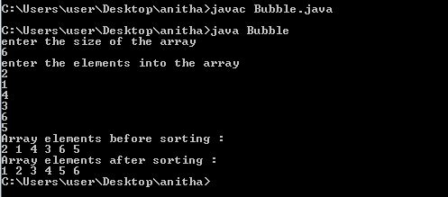

**9.Write a program to check whether the given string is palindrome or not**

import java.util.*;

class StrPalindrome

{

public static void main(String args[])

{

Scanner sc=new Scanner(System.in);

System.out.println("enter the string");

String original=sc.next();

StringBuffer st=new StringBuffer();

st.append(original);

StringBuffer reversed=st.reverse();

String s1=original.toString();

String s2=reversed.toString();

if(s1.equals(s2))

System.out.println(s1+" is a palindrome");

else

System.out.println(s1+" is not a palindrome");

}

}

**OUTPUT:**

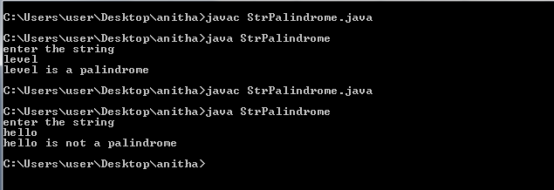

**10.Write a program to check whether the given number is palindrome or not**

import java.util.*;

class Palindrome

{

public static void main(String args[])

{

Scanner sc=new Scanner(System.in);

System.out.println("enter the number");

int num=sc.nextInt();

int originalnum=num;

int reversednum=0;

while(num!=0)

{

int remainder=num%10;

reversednum=reversednum*10+remainder;

num/=10;

}

if(originalnum==reversednum)

System.out.println(originalnum+" is a palindrome");

else

System.out.println(originalnum+" is not a palindrome");

}

}

**OUTPUT:**

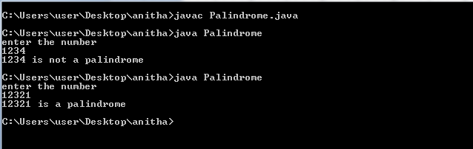

**11. This keyword**

**This with a variable**

Program to display details of a student using this keyword

class Student

{

int rollno;

String name;

float fee;

Student(int rollno,String name,float fee)

{

this.rollno=rollno;

this.name=name;

this.fee=fee;

}

void display()

{

System.out.println(rollno+" "+name+" "+fee);

}

}

class TestThis2

{

public static void main(String args[])

{

Student s1=new Student(111,"ankit",5000f);

Student s2=new Student(112,"sumit",6000f);

s1.display();

s2.display();

}

}

**OUTPUT:**

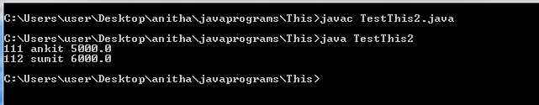

**This with a method**

class A

{

void m()

{

System.out.println("hello m");

}

void n()

{

System.out.println("hello n");

this.m();

}

}

class TestThis3

{

public static void main(String args[])

{

A a=new A();

a.n();

}

}

**OUTPUT:**

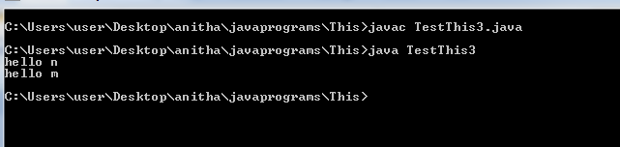

**This with a constructor**

class A

{

A()

{

System.out.println("hello a");

}

A(int x)

{

this();

System.out.println(x);

}

}

class TestThis4

{

public static void main(String args[])

{

A a=new A(10);

}

}

**OUTPUT:**

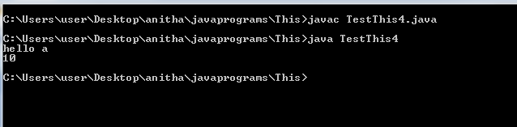

**12. Final Keyword Programs**

**Final Variable Demo**

class FinalVariableDemoa

{

final int speedlimit=90;//final variable

void run()

{

speedlimit=400;

}

public static void main(String args[]){

FinalVariableDemo obj=new FinalVariableDemo();

obj.run();

}

}//end of class

**OUTPUT:**

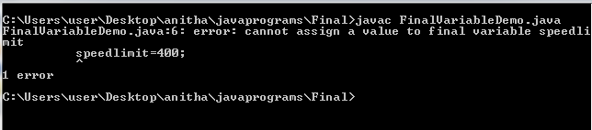

**Final Method Demo**

class Bike

{

final void run()

{

System.out.println("running");

}

}

class Honda extends Bike

{

void run()

{

System.out.println("running safely with 100kmph");

}

class FinalMethodDemo

{

public static void main(String args[])

{

Honda honda= new Honda();

honda.run();

}

}

**OUTPUT:**

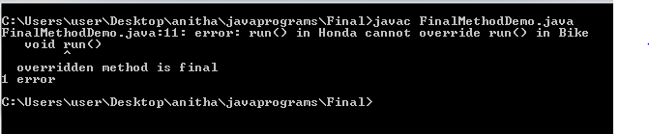

**FinalClassDemo**

final class FinalClassDemo

{

}

class Honda1 extends FinalClassDemo

{

void run()

{

System.out.println("running safely with 100kmph");

}

public static void main(String args[])

{

Honda1 honda= new Honda1();

honda.run();

}

}

**OUTPUT:**

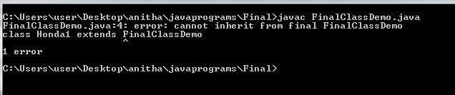

**13. Abstract Class Programs**

**Program to find the area of a rectangle and area of a triangle** using abstract class and abstract method

// Using abstract methods and classes.

abstract class Figure

{

double dim1;

double dim2;

Figure (double a, double b)

{

dim1 = a;

dim2 = b;

}

abstract double area (); // area is now an abstract method

}

class Rectangle extends Figure

{

Rectangle (double a, double b)

{ super (a, b);

}

double area () // override area for rectangle

{

System.out.println ("Inside Rectangle.");

return dim1 * dim2;

}

}

class Triangle extends Figure

{

Triangle (double a, double b)

{

super (a, b);

}

double area() // override area for triangle

{

System.out.println ("Inside Triangle.");

return dim1 * dim2 / 2;

}

}

class AbstractAreas

{

public static void main(String args[])

{

// Figure f = new Figure(10, 10); // illegal now

Rectangle r = new Rectangle(9, 5);

Triangle t = new Triangle(10, 8);

System.out.println("Area is " + r.area());

System.out.println("Area is " + t.area());

}

**OUTPUT:**

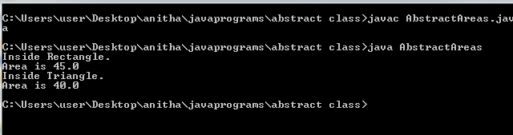

**Program to display rate of interest** using abstract class and abstract methods

abstract class Bank

{

abstract int getRateOfInterest();

}

class SBI extends Bank

{

int getRateOfInterest()

{

return 7;

}

}

class PNB extends Bank

{

int getRateOfInterest()

{

return 8;

}

}

class TestBank

{

public static void main(String args[])

{

Bank b;

b=new SBI();

System.out.println("Rate of Interest is:"+b.getRateOfInterest()+" %");

b=new PNB();

System.out.println("Rate of Interest is:"+b.getRateOfInterest()+" %");

}

}

**OUTPUT:**

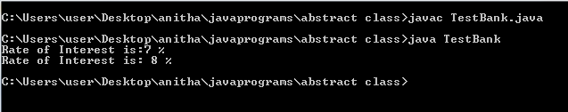

**14. Interfaces**

**Interface example program**

interface Printable

{

void print();

}

interface Showable

{

void show();

}

class MultipleInherit implements Printable,Showable

{

public void print()

{

System.out.println("Hello");

}

public void show()

{

System.out.println("Welcome");

}

}

class MultipleInheritDriver

{

public static void main(String args[])

{

MultipleInherit obj = new MultipleInherit();

obj.print();

obj.show();

}

}

OUTPUT:

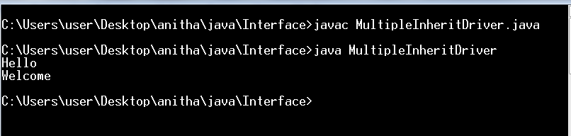

**15. Packages**

**Packages example program**

Save the file as **Addition.java**

**Compile it as:**

Javac -d . Addition.java

package mypack;

public class Addition

{

private double d1,d2;

public Addition(double a, double b)

{

d1=a;

d2=b;

}

public void sum()

{

System.out.println("Sum of two given numbers is:"+(d1+d2));

}

}

Save the file as **Subtraction.java**

**Compile it as:**

Javac -d . **Subtraction.java**

package mypack;

public class Subtraction

{

private double d1,d2;

public Subtraction(double a , double b)

{

d1=a;

d2=b;

}

public void difference()

{

System.out.println("Difference of d1 and d2 is:"+(d1-d2));

}

}

Save it as **Use.java**

Set the CLASSPATH variable as

set CLASSPATH=d:/5w3;.;

**compile it as**

**javac Use.java**

**run it by**

java Use

import mypack.Addition;

import mypack.Subtraction;

class Use

{

public static void main(String args[])

{

Addition obj1 = new Addition(10,20);

obj1.sum();

Subtraction obj2=new Subtraction(20,10);

obj2.difference();

}

}

**OUTPUT:**

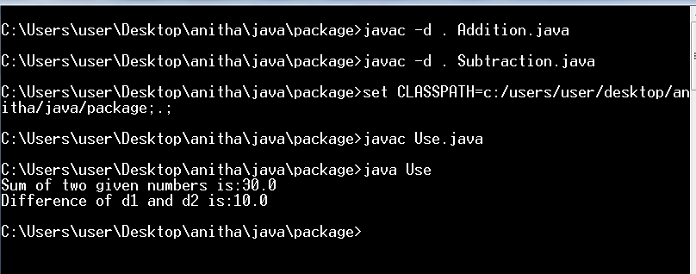

**16. Inner classes**

**Local Inner class example program**

public class TestLocalInner

{

private int data=30;

void display()

{

class Local

{

void msg()

{System.out.println(data);}

}

Local l=new Local();

l.msg();

}

public static void main(String args[])

{

TestLocalInner obj=new TestLocalInner();

obj.display();

}

}

**OUTPUT:**

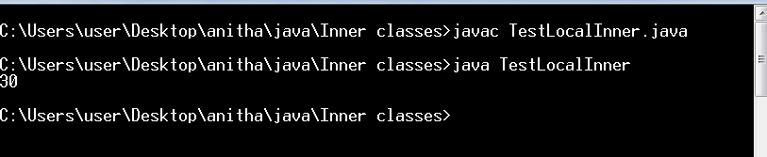

**Anonymous Inner class example program**

abstract class Person

{

abstract void eat();

}

class TestAnonymousInner

{

public static void main(String args[])

{

Person p=new Person()

{

void eat()

{

System.out.println("nice fruits");

}

};

p.eat();

}

}

**OUTPUT:**

